About Us

Zahid Ahmed:
Zahid Ahmed is a student of Bangladesh University of Business & Technology (BUBT) in dept. of CSE, Intake: 32, Sec: 02, ID: 15162103067.
Farhan Fardid:
Farhan Fardid is a student of Bangladesh University of Business & Technology (BUBT) in dept. of CSE, Intake: 32, Sec:02, ID: 15162103062.
Mohammad Emam Uddin Shahed:
Mohammad Emam Uddin Shahed is a student of Bangladesh University of Business & Technology (BUBT) in dept. of CSE, Intake: 32, Sec:02, ID: 15162103073.

1
Declaration

I hereby declare that the project entitled “Quizbook” is submitted in partial fulfillment requirements for the course of Software Development (iv) in the faculty of Computer Science & Engineering of Bangladesh University of Business & Technology (BUBT) in our own work and it contains non material which has been accepted for the award to the candidates of any other degree or diploma, except where due reference is made in the text of the project to the best of our knowledge.

Signature Signature
Farhan Fardid Md. Emam Uddin Shahed

Signature
Zahid Ahmed

2
Abstract

The concept of “Quizbook” since it is an android based application, we will keep everything as simple as possible. The project consists of the application that can be used by everyone. This will help them to gain general knowledge through the quiz.
“Quizbook” is an android based application to help the user to get the general knowledge. This system is able to provide service facility to the users to gain knowledge on different subjects or topics such as Computer, Sports, Invention, English, Author, Mathematics, Capitals and Currency of different countries of the world.

3

Acknowledgements

First and foremost, we are grateful to the Almighty Allah, the Merciful without whose patronage and blessing this project would not have been successfully completed. He gives us zeal, confidence, power of determination and courage and vanquished all the barrier that we have faced on the way. It is an auspicious moment for us as student of dept. of Computer Science & Engineering one of the prestigious academic center Bangladesh University of Business & Technology (BUBT) to express our deep feeling of gratitude to dept. and especially our honorable course teacher Md. Nahid Nawaz, lecturer, dept. of CSE for his wonderful guidance and inspiration and also for through review and correction of this dissertation work that could not be finalized without his astute supervision.

We pay profound regard to all of our teachers of the dept. for their very valuable direction and special attention. Our parents are very much keen and hopeful in the best performance of the dissertation we are going to submit. We wish we could fulfill their aspiration. We also pay regard to our friends in the dept. who through their interest and work are our contestant source of inspiration.

4
Table of Contents
- Introduction of the Project 6
  - Background of the Study
  - Statement of the Problem
  - Project Objectives
  - Scope of the Project
  - Software and Hardware Specification

- System Requirement Study 8
  - User Characteristics
  - Hardware Requirement
  - Software Requirement

- System Analysis 9
  - Study of Current System
  - Problems and Weakness of Current system
  - Feasibility Study
  - Methodology
  - Requirement and Analysis
  - Design
  - Coding/Implementation

- Implementation Planning and Testing 14
  - Implementation Environment
  - System Implementation
  - Testing

- Appendix 15
  - Features
  - Project Limitation
  - Time Factor
  - Project Budget
  - Difficulty Faced During Development
  - Scope of Future Application
  - Screenshots of the Project
- References 21
Introduction of the Project

Introduction:
Quizbook is a general knowledge information application for educational purpose for the user. It provides various information on different topics. User can easily develop a good knowledge about general information. We can summarize this in some point, they are:
- Users get to know many information about different topics.
- Can improve the basic general knowledges.
- Get to know about their level of the knowledge with a compliment.

Background of the Study:
Quizbook is an android application that has general questions related to current affairs on different types of topic. It has multiple choice questions with time limit and in the end the scores is showed depending on the correct answer. The output shows how many answers are correct among the number of question that one has answered within the time limit. Each incorrect answer can improve the knowledge students by providing the correct answer of that question. It helps in increasing general knowledge about world, sports, inventions of things, mathematics, computer etc.
Statement of the Problem:
Most of the students or user do not have a good general knowledge on different subjects or topics. One can gain or improve his or her general knowledge by reading regularly about different things or the specific subject on which they want to gain knowledge. They don’t know about everything or don’t have any knowledge about some topics. By using this simple app they can easily learn about some topics at most of the times. Often they do not check updated news or information so they remain unknown about that topic.

6

Project Objectives:
The main objective of Quizbook is to facilitate a user friendly environment for all users and reduces the manual effort. In past days quiz is conducted manually but in further resolution of the technology we are able to generate the score and pose the queries automatically. The functional requirements include to create users that are keen to participate in the quiz & automatic score and report generation about their level of general knowledge. Tasks like add, delete, update or admin privilege users. In this application all the permissions lies with the administrator i.e specifying the details of the quiz with checking result will show in the end.

Scope of the Project:
The Quizbook application is to replace the old and traditional system of learning. It provides capabilities for knowing basic general knowledges about different types of subject or topics.
By developing the system we can attain the following system:

- Users can get the information easily.
- Easy to handle and use.
- Efficient, fast and convenient way of learning.

Software and Hardware Specification:
Hardware specification:
-Laptop, Computer, Android Mobile.
Software specification:
-Microsoft windows XP/7/8/10 operating system.
- Android version Gingerbread 3.4 -3.4.7 or above.
- NetBeans.
-JDK.
-Android Studio.
7
System Requirement Study

User Characteristics:
Basically the users should have:
-A system that improves on the efficiency of information.
-A system that is easy to learn and use.
-A system that is flexible, safe and convenient.

Hardware Requirement:

Section | Requirements and Recommendations
Supported Operating Systems | Microsoft Windows 7 32/64 bit  Microsoft Windows 8 32/64 bit
Additional Software Requirements | Adobe Acrobat Reader 4.0 or higher
Display | Minimum resolution 800 x 600 pixel  1024 x 768 pixel recommended
RAM | 4 GB or more recommended especially for Microsoft Windows Vista, 7 and 8
CPU | 1.5 GHz processor speed or higher

Software Requirement:
Section | Requirements and Recommendations
Supported Operating Systems | Microsoft Windows 7 32/64 bit
Additional Software Requirements | JDK, Android Studio, NetBeans.
8
System Analysis
Study of Current System:
Quizbook is an android application that has general questions related to different topics of current times. It has multiple choice questions with time limit and it also shows the result in the end by displaying the number of correct answers among all the questions the one has given answer within the limited time. It is good for every users, it helps to increase general knowledge about computer, sports, authors, inventions etc. one just need to register simply i.e any user name and password, it will be saved automatically and you can login using same user name and password don’t have to worry about the past score!

Problems and Weakness of Current system:
- System is quite secure and safe but there are also some lacking in the system.
- The apps has some problem regarding the different topic score calculation.

Feasibility:
Financial Feasibility:
This procedure is used to determine the benefits and savings that are expected from candidate system and compare them with the cost. The benefits outweigh the cost and the decision is made to design and implements the system. Bug fixes and maintaining tasks will have an associated cost.

Technical Feasibility:
Technical feasibility centers on the exiting computer system and what extent it can support the
Proposed addition. We have to keep in mind the capacity of the proposed system and make an effort not to over load the system. Each of the technologies are available and the technical skills required are manageable. Time limitations of the product development and the ease of implementing using these technologies are synchronized. From these it’s clear that the project OES is technically feasible.

9
Resource and Time Feasibility:
Resource feasibility
Resources that are required for the Quizbook project includes:
Programming device (Laptop)
Programming tools (freely available)
Programming individuals.
Data Server.
So it is clear that the project OES has the required resource feasibility.

Operational Feasibility:
This involves undertaking a study to analyze and determine whether the system needs can be fulfilled by using the proposed solution. It also measures how well the proposed system solves problems and takes advantage of the opportunities identified during scope definition. Operational feasibility studies also analyze how the project plan satisfies the requirements identified in the requirements analysis phase of system development. To ensure success, desired operational outcomes must inform and guide design and development. These include such design-dependent parameters such as reliability, maintainability, supportability, usability, disposability, sustainability, affordability, and others.

Risk Feasibility:
In this project, there are some risk feasibility available:

- Estimated size of the product in line of codes:
As the system doesn’t contain any multimedia aspect, the file sizes and the complete
Project size will not exceed 20MB.

- Development Environment Risk:
Development environment risks
Is a software project management tool available?
Are tools for analysis and design available?

Technical issue risks: Failure of the used technique can eventually arise and can affect the outcome.
Are software configuration management tools available?
Configuration management will be done using GIT that is freely available?
Technical issue risks are specific conventions for code documentation defined and
Used?
Software code will be freely available and the code documentation will be provided.

10
Do you use a specific method for test case design?
JUNIT will be use as the main testing tool that
Automates the testing process.
Are configuration management software tools used to control and track change activity
Throughout the software process?

Methodology:
- Requirement Gathering and analysis − All possible requirements of the system to be developed are captured in this phase and documented in a requirement specification document.
- System Design –The requirement specifications from first phase are studied in this phase and the system design is prepared. This system design helps in specifying hardware and system requirements and helps in defining the overall system architecture.
- Implementation –With inputs from the system design, the system is first developed in small programs called units, which are integrated in the next phase. Each unit is developed and tested for its functionality, which is referred to as Unit Testing.
- Integration and Testing − All the units developed in the implementation phase are integrated into a system after testing of each unit. Post integration the entire system is tested for any faults and failures.
- Deployment of system − Once the functional and non-functional testing is done; the product is deployed in the customer environment or released into the market.
- Maintenance − There are some issues which come up in the client environment. To fix those issues, patches are released. Also to enhance the product some better versions are released. Maintenance is done to deliver these changes in the customer environment.

11

Requirement and analysis:

At this stage we will gather information about what the system needs and define the problems the system is expected to solve. We will also gather requirement such as tools like the programming language to use and hardware needed.

Design:
At this stage, we will make an overall design of the system architecture and physical design which includes user interface. It is at this stage that we will identify any faults before moving onto the next stage. The output of this stage is the design specification which is used in the next stage of implementation.

Coding/Implementation:
At this stage, we will begin coding as per the design specification. The output is one or more product components built according to a pre-defined coding standard and debugged, tested and integrated to satisfy the system architecture requirement.

12

Implementation Planning and Testing

Implementation Environment:
This section is about understanding the background of the project study, definition of the project problem statement, its objectives, scopes, project justification, risks, project deliverables and project budget and project schedule.
It is the phase where visions and plans become reality. This is the logical conclusion, after evaluating, deciding, visioning, planning, applying for funds and finding the financial resources of a project. Technical implementation is one part of executing a project.

System Implementation:

Systems implementation is the process of-
#defining how the information system should be built
#ensuring that the information system is operational and used.
#ensuring that the information system meets quality standard.
If all this process is successfully installed then we can say that the required system is perfectly implemented.
Several activities included also:
*End user training.
*End user education.
*Training on the application software.
*Post implementation Review.

13

Testing:
System testing has dual function. It is used to identify the defects in program and it is used to help judge whether or not program is usable in practice. Thus software testing is used for validation and verification, which ensure that software conforms to its specification and meets need of the software customer.
The alfa testing, which usually comes in after the basic design of the program has been completed. The project will look over the program and give suggestions and ideas to improve the implementation. They also give ideas to get rid of around any major problems. All the units developed in the implementation phase are integrated into a system after testing of each unit. Post integration the entire system is tested for any faults and failures.
Software testing is an investigation conducted to provide stakeholders with information about the quality of the software product or service under test. Software testing can also provide an
Objective, independent view of the software to allow the business to appreciate and understand the risks of software implementation. Test techniques include the process of executing a program or application with the intent of finding software bugs, errors or other problems and verifying that the software product is fit for use.

14

Appendix

Features:
- Users get to know many information about different topics.
- One can improve the basic general knowledges.
- One gets to know about their level of the knowledge with a compliment.

Project Limitation:
There are some limitations in this project. Although we have tried to make a successful project but there are some limitations.

- Due to security requirements local user cannot use all utilities and modify system settings.

Difficulty Faced During Development:
Our development team faced at first the funding difficulties during developing the system. We also face difficulties during designing user interface. The application did not run at the first attempt. But after working few days more we overcome the problem and run the application successfully.

Scope of Future Application:
We think this project would help students so much and we also hope that we can improve this web in future.

- In the future user can also be able to upload his or her scores on social media via this app.
- We can run the entire system in any operating system and also we have IOS application of this entire app

15
Time Factor:
Stage 1 | Analysis and Design | hours
1.1 | Requirements analysis, Mock ups creation | 12
1.2 | Work plan creation | 4
Stage 2 | Implementation
2.1 | App design creation | 10
2.2 | Database creation | 8
2.3 | General system functionality, user management | 15
2.4 | Multiple recipients’ postcards functionality | 10
2.5 | Orders status back end functionality | 14
2.6 | Additional pages of content, multiple language support | 12
Stage 3 | Testing and other QA tasks
3.1 | Testing and bugs fixing | 25
Stage 4 | Deployment | 6

Project Budget:

We have estimated a budget of total 500 USD for the project. It includes all the required costs and other maintenance costs for a certain period of time.

16

Screenshots of the Project:
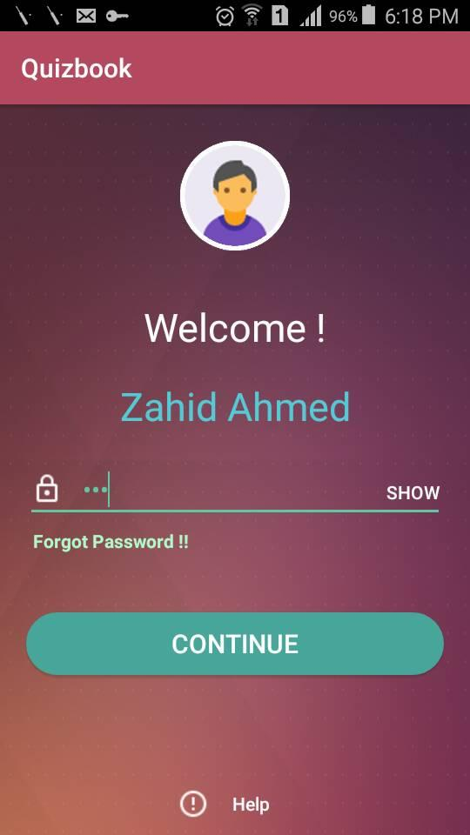

17
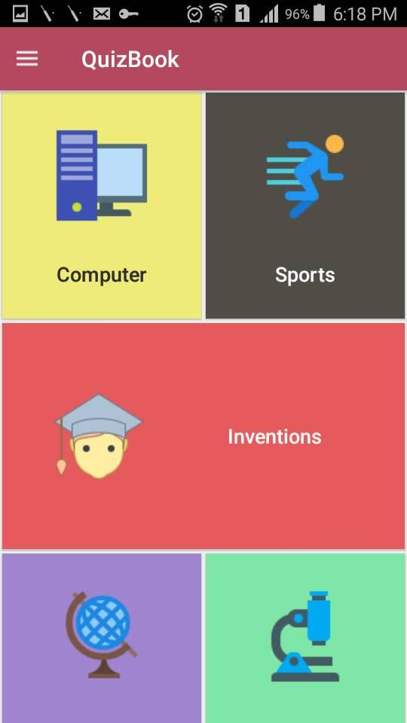
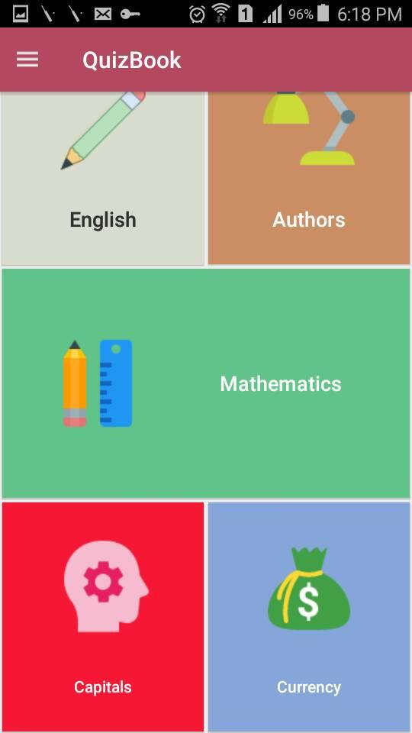

18
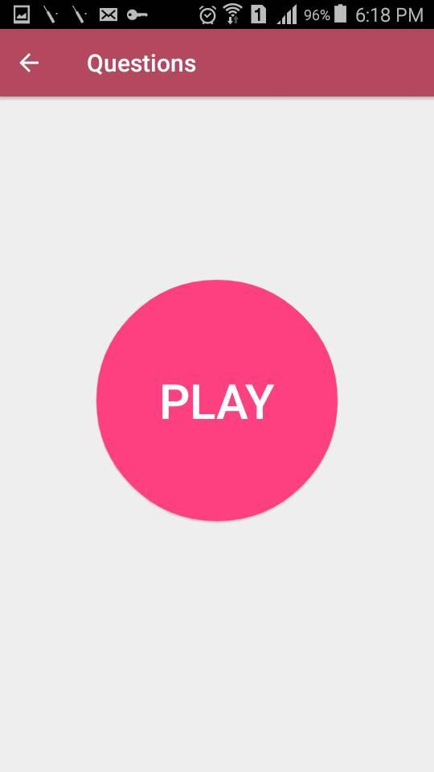
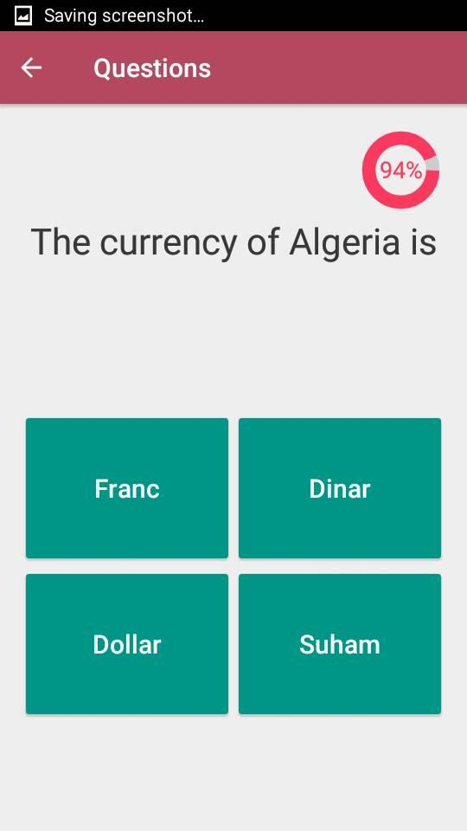
19
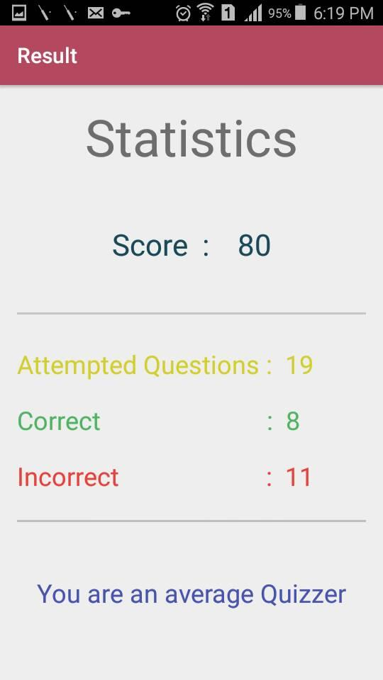
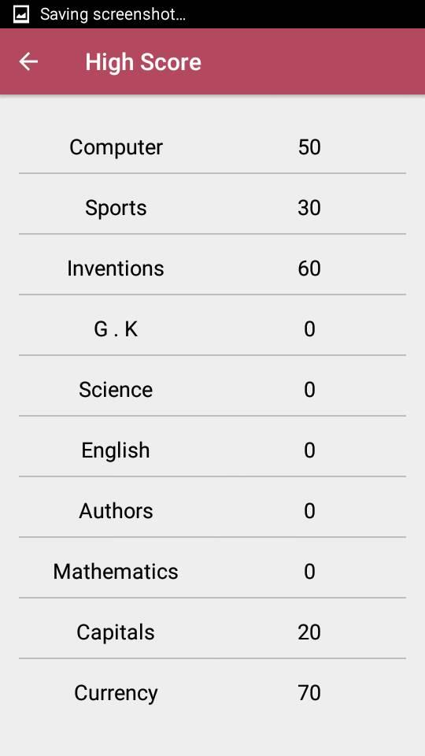
20

References

- Google
- Wikipedia
- Tutorials point
- Slide share
- w3schools
- Bootstrap
- Stack overflow

21

